Resource group in EUS and SEA

az group create -l eastus -n EUS-RG

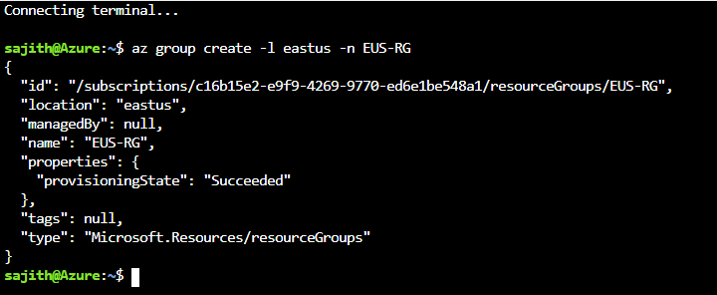

az group create -l southeastasia -n SEA-RG

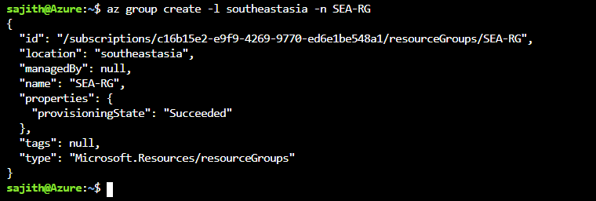

**VNET-SEA**

az network vnet create \

--name vnet-SEA \

--resource-group SEA-RG \

--subnet-name default

**VNET-EUS**

az network vnet create \

--name vnet-eus \

--resource-group EUS-RG \

--subnet-name default

**NSG**

az network nsg create -g SEA-RG -n SEA-WEB-NSG --tags super_secure no_80 no_22 no_3389

az network nsg create -g EUS-RG -n EUS-WEB-NSG --tags super_secure no_80 no_22 no_3389

**peering**

az network vnet peering create -g SEA-RG \

-n sea-eus --vnet-name vnet-SEA \

--remote-vnet eus-sea --allow-vnet-access

az network vnet peering create -g EUS-RG \

-n eus-sea --vnet-name vnet-eus \

--remote-vnet sea-eus --allow-vnet-access

**Backup of web servers**

az backup vault create --resource-group SEA-RG \

--name SEA-webservers-backup \

--location southeastAsia

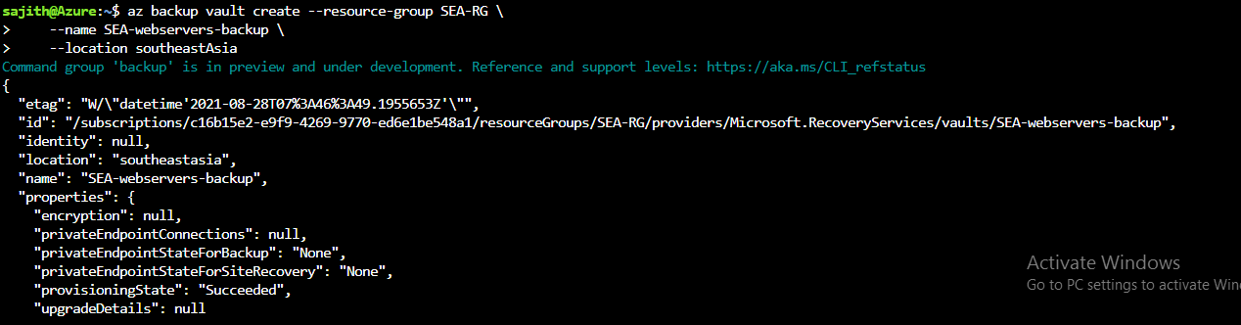

az backup protection enable-for-vm \

--resource-group SEA-RG \

--vault-name SEA-webservers-backup \

--vm ${vm[0]} \

--policy-name DefaultPolicy

az backup protection enable-for-vm \

--resource-group SEA-RG \

--vault-name SEA-webservers-backup \

--vm ${vm[1]} \

--policy-name DefaultPolicy

**Create storage account**

**# Creating a Storage Account**

**SEA data resources must provide high resiliency in case of even multiple azure data center failures**

az storage account create -n seastorageact \

-g SEA-RG -l SoutheastAsia \

--sku Standard_GRS \

--kind BlobStorage

**EUS based resources should provide data resiliency in case of azure datacentre failure**

az storage account create -n nileusstorage \

-g EUS-RG -l East US \

--sku Standard_ZRS

--kind BlobStorage

**Sales manager should access his resource from windows explorer**

## Storage Share

az storage share create --account-name nileusstorage \

--name sales_share

--quota 1

az storage share create --account-name seastorageact \

--name sales_share

--quota 1